Inventory Management Software

Inventory A+

Introduction:

Inventory A+ is a software that automates the classic way of keeping track of the contents/products in an inventory. This software aims to help the user in managing the list of the items in the inventory, tasks that include adding /removing items, changing the quantity in stock

Objectives:

* Implement the usage of database management tools such as SQLite
* To use Python programming language in making the software
* Use different methods in member collaboration and project planning

Scope and Limitations:  
this software is only limited to the management of inventory items. Due to this, only the authorized person(s) may be allowed to view the contents of the database. This program does not allow customers to buy products from the store,

Functions:

* Register – allows the user to create a new account with the credentials the user provides
* Add item – adds an item with its corresponding quantity to the database
* Delete item – a case sensitive manual deletion of an item in the database
* Edit Quantity – searches for an item in the database and changes its quantity
* Sort item – sorts the contents of the database
* Refresh database – refreshes the list of the contents of the database

Product Backlog

1. User Login – allows the user to login and access the main database  ✔
2. Login error – displays the error message when entering invalid credentials ✔
3. Account creation – the user can make a new account with own(new) set of data ✔
4. Username exists error – displays the error message whenever an attempt to register with the same username exists ✔
5. Add item function – allows the user to add an item into their database ✔
6. Delete item function – allows the user to delete an item in their database ✔
7. Edit item function – allows the user to edit the quantity of an item in their database ✔
8. Sort item function – allows the user to sort the items in the database ✔
9. Refresh database function – allows the user to display/refresh the contents of their database ✔

User Interface

Login Page

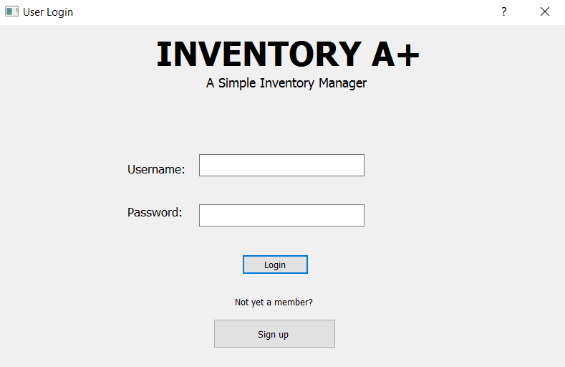

Register page

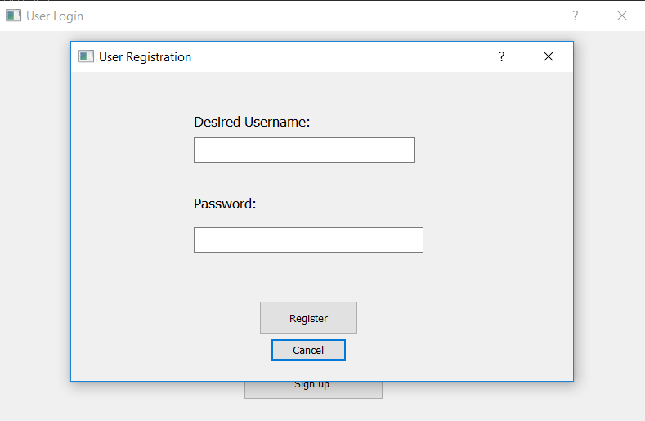

Main Database page

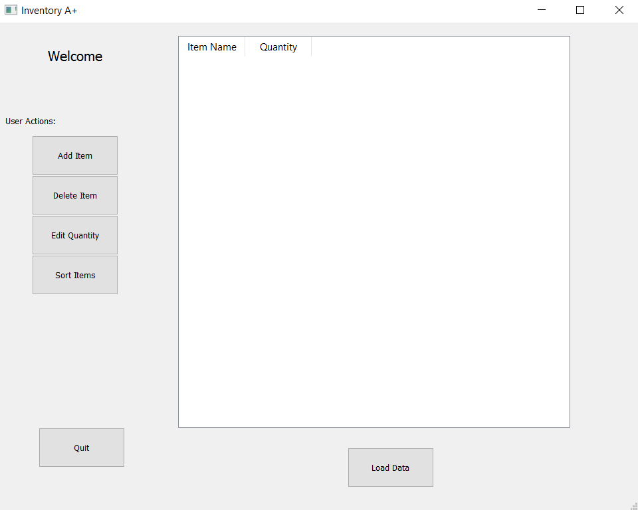

Add Item

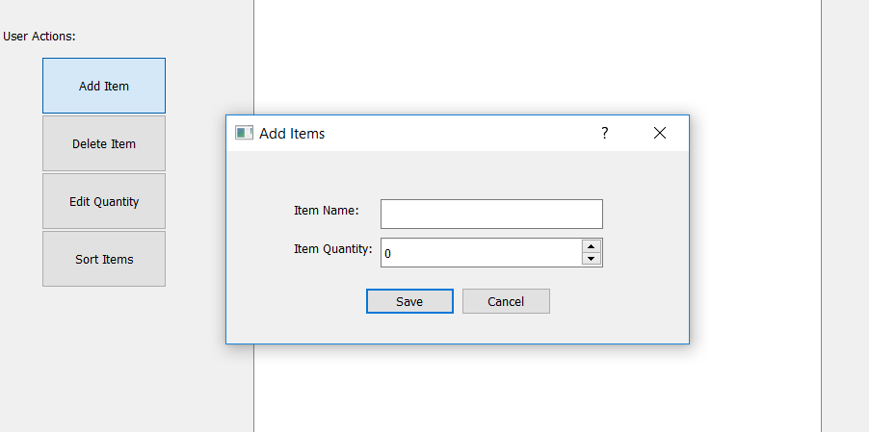

Delete Item

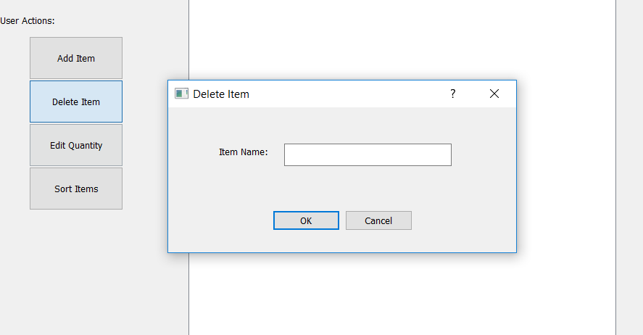

Edit Quantity

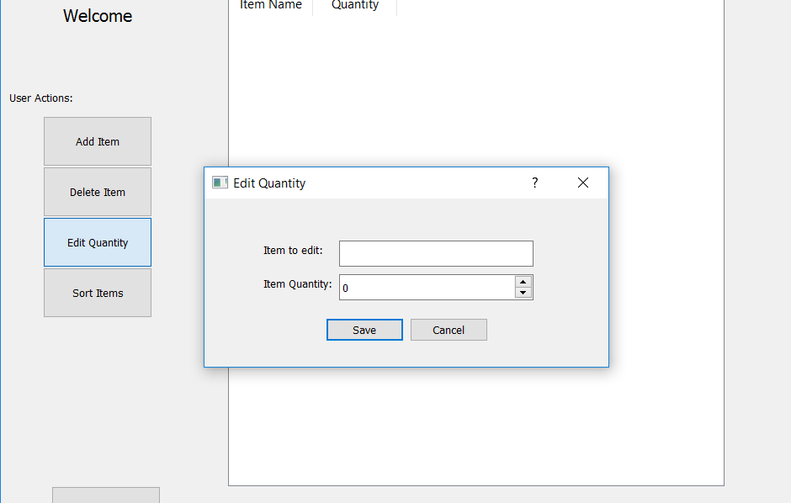

Use Case Diagram

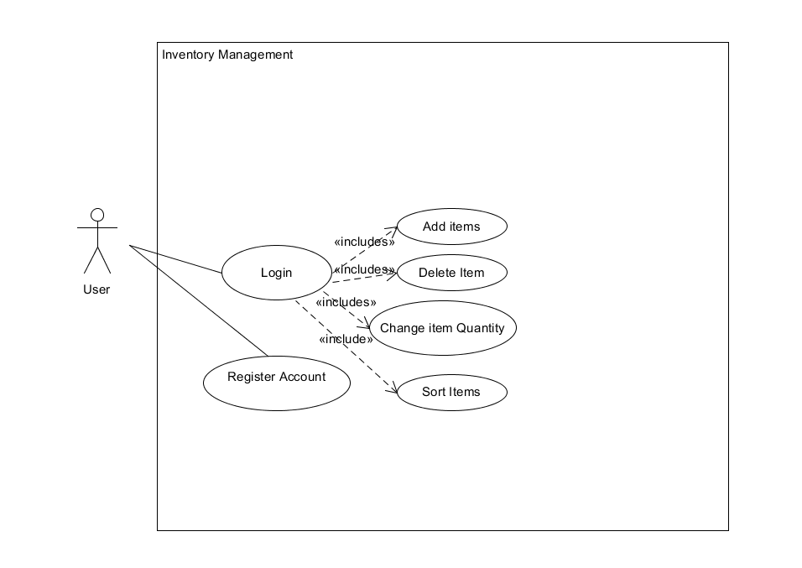

The use case diagram above shows the actions the user can take when using the program, the user can either choose to register an account or login with an existing account in order to access the main database and its features.

Conceptual Class Diagram

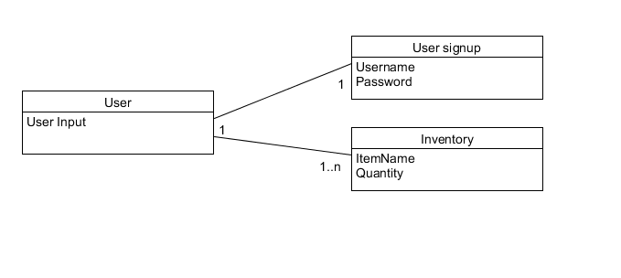

Detailed Class Diagram

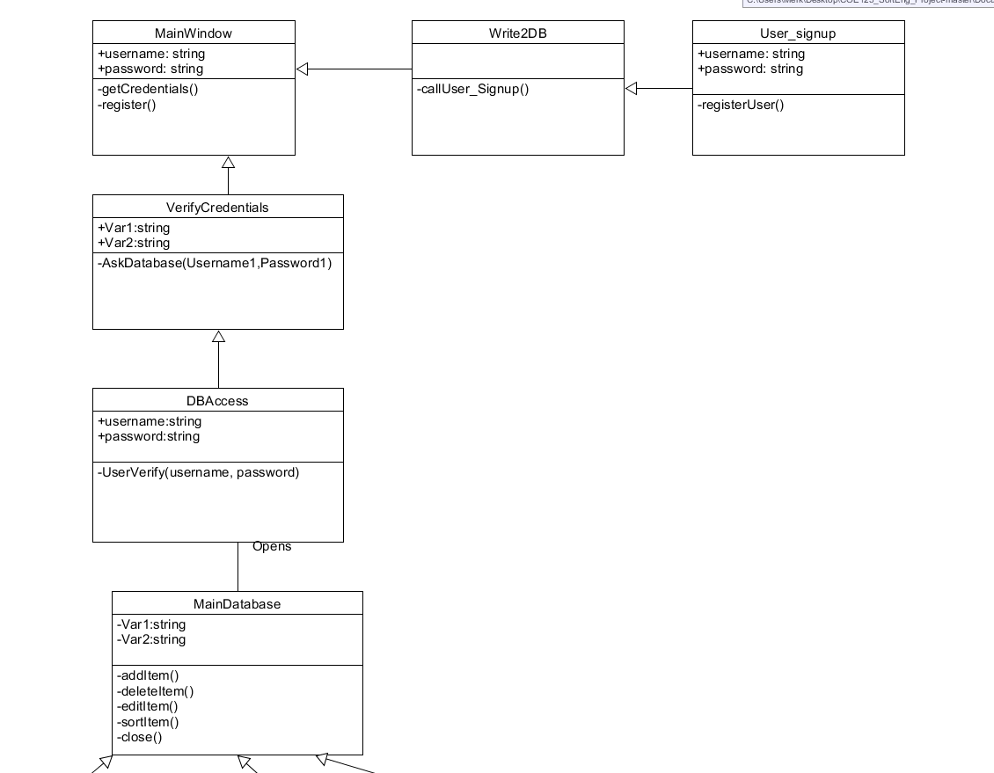

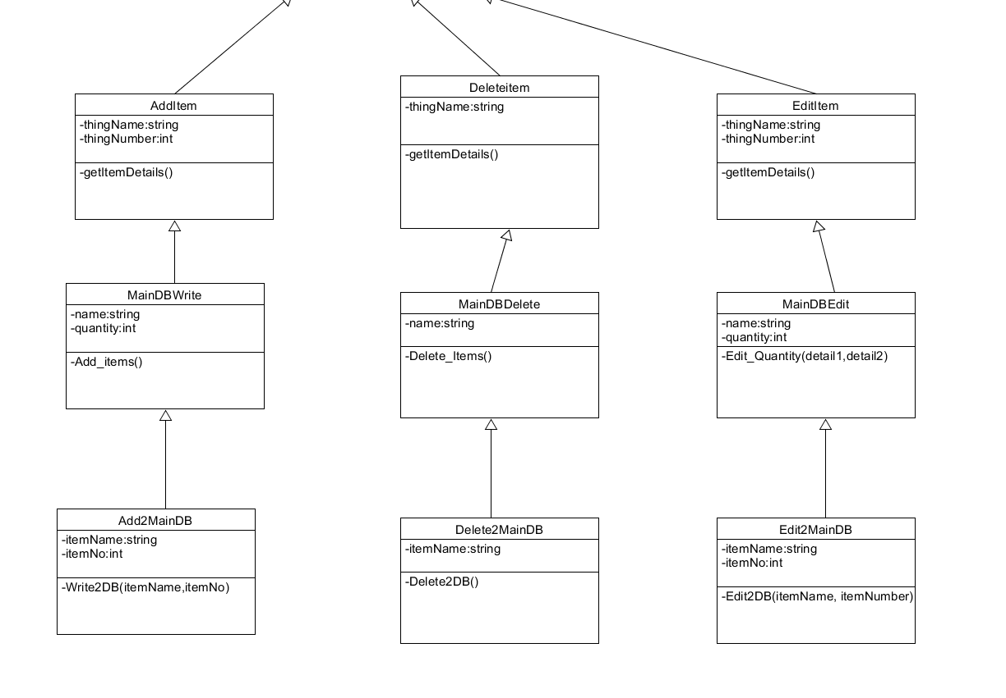

Unit Testing

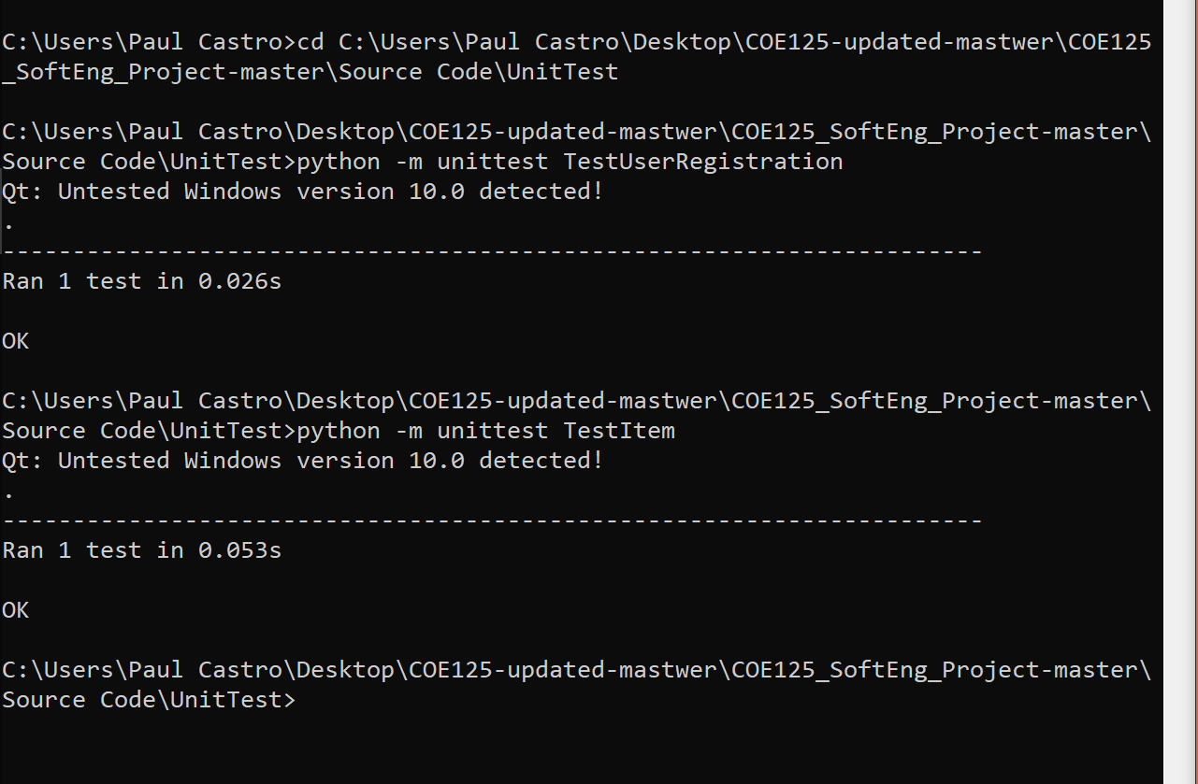

Sprint 1 partial codes

* Main.py
* registerSucc.py
* RegisterError.py
* LoginErr.py
* Signup.py

Sprint 2 partial codes

* AccountR_W.py
* AppendMainDB.py
* EditQuantityFromMainDB.py
* RemoveFromMainDB.py
* Check_Acc_from_DB.py
* DeleteFromMainDB.py
* EditFromMainDB.py
* Write2MainDB.py

Sprint 3 partial codes

* DeleteComplete.py
* DeleteFailed.py
* Quantity_Editfail.py
* Quantity_Editsuccess.py
* LoggedUser.py
* Display2MainDB.py